Additional info - https://www.monmouthshire.gov.uk/social-care/carers-project/
A link to a carers pages on MCC website https://www.monmouthshire.gov.uk/social-care/carers-project/

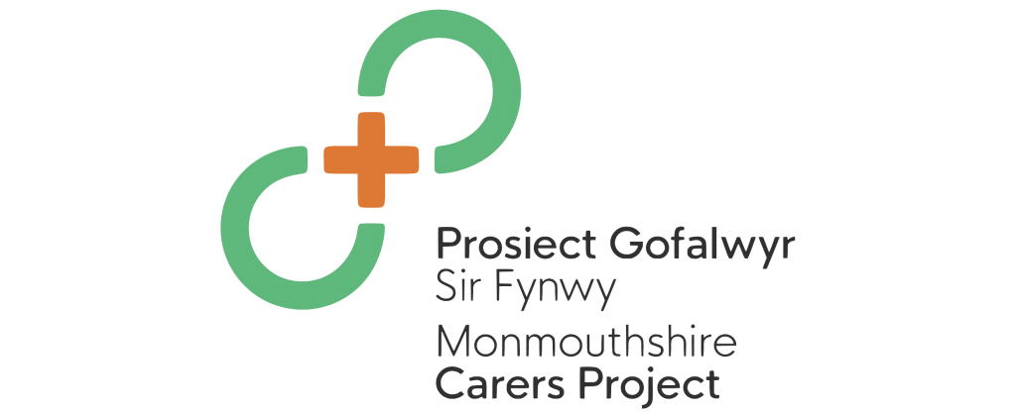

If you are a carer and would like to be involved in trying out some of these new opportunities using digital technology – please register with us and we can send you the details and invitations as events are organised.

We can provide handbooks for carers, help when planning for emergencies, a newsletter and events and updates.

